Node Placement and Connection

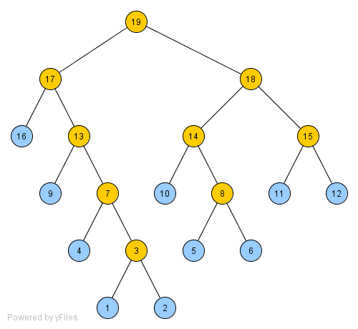
After sorting the elements in ascending order, the nodes can be placed and connected as such:
1. Place for first item in list
2. Place for second item in list
3. Node to connect leaf one and leaf two
4. Place for third item in list
5. Place for fourth item in list
6. Place for fifth item in list
7. Node to connect leaf three and parent node one
8. Node to connect leaf four and leaf five
9. Place for sixth item in list
10. Place for seventh item in list
11. Place for eighth item in list
12. Place for ninth item in list
13. Node to connect leaf six and parent node two
14. Node to connect leaf seven and parent node three
15. Node to connect leaf eight and leaf nine
16. Place for tenth item in the list
17. Node to connect leaf ten and parent four
18. Node to connect parent five and parent six
19. Node to connect parent seven and parent eight

Notice how the next two items are added there are enough to connect to a new one to the parent of another. For each one added to group in with a parent, this represents the smallest of that set being grabbed from the list. The last two added constitute the two highest of the group be grabbed and thus do well as being leaves so there parent will eventually add of to the highest numbers of the new set of parents being created in the future steps. So if the nodes are grabbed in the order previously prescribed, we come up with a code assignment of 00, 111, 110, 100, 010, 1011, 1010, 0110, 01111, 01110. So this translates to: 1,000 * (2 * 25 + 3 * 14 + 3 * 12 + 3 * 12 + 3 * 11 + 4 * 8 + 4 * 7 + 4 * 5 + 5 * 4 + 5 * 2) = 307,000.
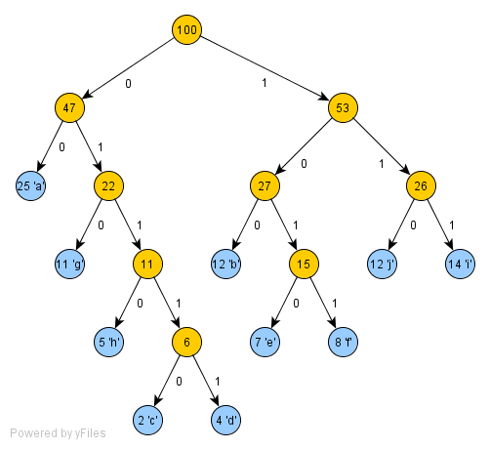
Truly

